CSE 219 — Signals and Linear Systems
Lec 5–6 · Fourier Series and Its Properties
Lesson notes · Exam approach · TF practice with solutions · Quick notes (Anik Sir's portion)

How to Read These Notes
EXAM FOCUS | Exam importance, where it appears in the TF collection
MEMORIZE | Rules, tables and formulas to memorize
TRAP | Common mistakes and exam traps
EXAM-READY ANSWER | Model wording you can write in the exam
NOTE | Extra explanation / clarification
Grey box, monospace | Code, worked tables, derivations and hand-drawn sketches
Centered grey box | Formula to remember / final numerical result
Purple heading / ✔ green | Practice questions / their solutions

Contents
Exam Map — What the TF Papers Ask — Fourier-series questions and their weight
Lesson 11 — The Idea of Fourier Series; Orthogonality and Convergence — harmonics, the coefficient formula, orthogonal sets, Dirichlet
Lesson 12 — Computing Coefficients — by inspection, by integration; square wave, ramp; trigonometric form
Lesson 13 — Linearity, Shift, Reversal, Scaling and Symmetry — coefficient rules; real/even/odd/half-wave
Lesson 14 — Differentiation, Impulses, Impulse Trains, Integration — jkω₀ rule, impulse train a_k = 1/T, sawtooth
Lesson 15 — Multiplication, Parseval, and Periodic Inputs to LTI Systems — coefficient convolution; y_k = H(jkω₀)a_k
Quick Notes — Fourier Series — merged revision notes + key diagrams
NOTE Slide numbers refer to Lecture-5-Fourier-Series-Let's-Look-Inside.pdf (53 slides, “Lec 5”) and Lecture-6-Properties-of-Fourier-Series.pdf (82 slides, “Lec 6”). Orthogonal function sets, Dirichlet conditions, half-wave symmetry, Parseval's relation and the response of an LTI system to a periodic input are textbook background (marked); the EEE and CSE 311 papers ask them often.

Exam Map — What the TF Papers Ask
Fourier series appear in every paper: a full 30-mark question in CSE 219 2023-24 (Q4) and two to three parts in every EEE paper.
Session (paper) | Questions answered by this note
2023-24 (CSE 219) | Q4(a) Odd square wave (±A), y = x(t−T₀/6): half-wave symmetry? (5) · Q4(b)–(d) Y_k of the shifted square wave; magnitude/phase spectra to k=5; compare with trig FS (25)
2023-24 (EEE 211) | Q7(a) Three functions pairwise orthogonal on (−1,2); A for orthonormal (10) · Q7(b) Half-wave rectified sine (T=0.5 ms) → differentiator & LPF (1 kHz, gain 5): FS of y₁, y₂(t) (25)
2022-23 (CSE 219) | Q5(d) x(t) = Σ_{k=0}¹⁰⁰ (½)^k e^{jk2πt/50}: real-valued? even? (5)
2022-23 (EEE 211) | Q5(a) Compact trig FS of 2+3cos2t+4sin2t+2sin(3t+30°)−cos(7t+150°); amplitude spectrum (10) · Q7(a) Exponential FS of the periodic waveform of Fig. 7(a) (20) · Q8(a) Trig FS of the impulse train δ_{T0}(t); amplitude spectrum (20)
2022-23 (CSE 311) | Q1(a) FS coefficients: even signal → real, odd → imaginary; cos 2πf₀t (17)
2021-22 (EEE 211) | Q3(a) Periodic x (T=4) = δ(t−1)+2[u(t−2)−u(t−4)] into LC–R circuit: spectra of x and y (20) · Q3(b) Orthogonal set on (−2,2); orthonormalise; expand x = 1 on [0,2]; Parseval (15)
2020-21 (EEE 211) | Q7(a) Triangle wave x: exp FS; y (rect train) via FS properties; amplitude spectra (20) · Q7(b) y''+3y'+2y = x'+x, x = 2cos t + 6cos 3t: spectra of y; average power (15)
2020-21 (CSE 311) | Q2(b) Exponential FS coefficients of sin 2πt and cos 2πt; need a full cycle? (17)
2019-20 (EEE 211) | Q5(b) Full-wave rectified sin t into RC low-pass (15 Ω, 1/5 F): H(ω), y(t) (20) · Q7(a) Exponential FS of the two impulse trains of Fig. 7(a) (15) · Q8(b) Trig FS a₀, aₙ, bₙ of the triangular wave of Fig. 8(b) (20)
2019-20 (CSE 311) | Q1(a) Why cos/sin 2πf₀t has a FS; are its exp. FS coefficients real or imaginary? (17)
2018-19 (EEE 211) | Q1(a) Orthogonality condition; e^{j2t}, e^{j4t} orthogonal on [0, π]? (10) · Q1(b) x = 2+½cos(t+45°)+2cos3t−sin(4t+30°): exp FS; magnitude/phase spectra (10) · Q1(c) Triangular wave (T=4, A=4) into R = 100 Ω + L = 0.1 H: power in R (15) · Q3(c) C_n = 1 (odd n), T = 2, through band-pass H with ±π/2 phase: h(t), output (15)
2018-19 (CSE 311) | Q2(b) Even → real, odd → imaginary FS coefficients; half-cycle integration (15)
2017-18 (EEE 211) | Q1(a) Orthogonal signals; show φ₁, φ₂, φ₃ orthogonal; T for orthonormal (12) · Q1(c) H = 1 for |ω| ≤ 3π; x = 1+2cos2πt+cos4πt+½cos6πt: exp FS, y, spectra (15) · Q4(a) Trig FS coefficients of 3 + cos(4t+π/4) + sin(10t+π/3) (12)
2016-17 (EEE 211) | Q2(a) Dirichlet conditions for FS convergence (10) · Q2(b) Pulse train: exp FS, power (Parseval), FS of dx/dt, output of 1/(1+jω), spectra (25) · Q3(a) Orthogonal set; T for orthonormal; express x = A on (0,T) (15)
2015-16 (EEE 301) | Q4(a) Periodic x (FS given) into R–L–C circuit: y(t); distortionless? (20) · Q4(b) x = cos4πt, y = sin4πt (T = ½): FS of z = xy by multiplication property (15) · Q6(a) Impulse train: FS, FT and power spectral density (10)
2014-15 (EEE 301) | Q4(a) C_n = ½[1−(−1)ⁿ], T = 20 ms: real signal? time-domain signal (18) · Q4(b) C_n = e^{jnπ/3}/(n²+1) into L–C–R circuit: first four harmonics, average of output (17)
2013-14 (EEE 301) | Q3(a) Do tan(2πt) and sin(2π/t) have convergent FS? (18) · Q3(b) Exponential FS of the triangular wave (peak 2, period π) (17) · Q4(b) x = B + A cos(ω₀t+θ) into L–C–R circuit: y(t) (17)
2012-13 (EEE 301) | Q4(a) Express x(t) of Fig. 4(a) in the basis φ₁, φ₂, φ₃ on [0,3] (17) · Q4(b) Half-wave rectified cos t into L–C–R circuit: 2nd and 4th harmonics of y (18)
2011-12 (EEE 301) | Q1(a) Real odd, T = 2, c_k = 0 for |k|>1, ½∫|x|² = 1: two signals (18) · Q1(b) H = sin4ω/ω, periodic square input: output by FS (17)
2010-11 (EEE 301) | Q1(a) Square wave K, width τ, period T: C_n; spectra for τ=1, T=5,10,15 (18) · Q1(b) x = A e^{j10³t} into RC circuit: H, magnitude/phase, y(t) (17)

EXAM FOCUS Most asked: (1) coefficients by inspection from a sum of sinusoids (EEE every year, 10–17 marks) · (2) coefficients of a standard periodic waveform (square, triangle, rectified sine, impulse train) · (3) use properties instead of integrating — shift, derivative (CSE 219 2023-24 Q4, EEE 2020-21 Q7(a)) · (4) periodic input through an LTI filter: y_k = H(jkω₀)a_k (EEE 2023-24 Q7(b), 2019-20 Q5(b)) · (5) even → real, odd → imaginary coefficients (CSE 311 three times).

Lesson 11 — The Idea of Fourier Series; Orthogonality and Convergence
Slides 2–23, 44–52 (Lec 5) · orthogonal sets and Dirichlet conditions: textbook

1. Periodic Signals as Sums of Harmonics (sl. 2–17)
Any periodic signal can be split into simple waves; each simple wave is easy to handle (a vibrating string, heat diffusion), and the answers are added back. A signal of period T contains only frequencies kω₀, ω₀ = 2π/T (bells ringing every 2, 3, 5 min repeat every lcm = 30 min, sl. 10–11).
x(t) = Σ_{k=−∞}∞ a_k e^{jkω₀t} ω₀ = 2π/T

2. Finding a_k: Stop the Rotation and Average (sl. 18–22)
The average of e^{jkω₀t} over one period is 1 for k = 0 and 0 otherwise. Multiply x(t) by e^{−jkω₀t}: the k-th term stops rotating, every other term still rotates and averages to zero.
a_k = (1/T) ∫_T x(t) e^{−jkω₀t} dt a₀ = average value of x

3. Coordinates and Projections (sl. 44–52)
Functions have coordinates just like vectors: 3 + 2t ↔ (3, 2) in the basis {1, t}; eᵗ ↔ (1, 1, 1/2!, …) in {1, t, t², …}. Fourier series uses the basis {e^{jkω₀t}}, and the coordinate is a projection with the inner product ⟨x, z⟩ = (1/T)∫_T x z* dt. With z = e^{jkω₀t} this is exactly a_k.

4. Orthogonal and Orthonormal Sets (textbook)
- φᵢ, φⱼ are orthogonal on (t₁, t₂) if ∫ φᵢ φⱼ* dt = 0 (i ≠ j); orthonormal if also ∫|φᵢ|² dt = 1.
- Normalize: divide φᵢ by √Eᵢ, Eᵢ = ∫|φᵢ|².
- Expansion: x ≈ Σ cᵢ φᵢ with cᵢ = ∫ x φᵢ* dt / Eᵢ (best least-squares coefficients).
- Parseval for the set: ∫|x|² dt = Σ |cᵢ|² Eᵢ when the set is complete for x.

5. Dirichlet Conditions (textbook)
A periodic x(t) has a Fourier series that converges to x(t) at every point of continuity (and to the midpoint of each jump) if, over one period: (1) it is absolutely integrable, ∫_T|x|dt < ∞; (2) it has a finite number of maxima and minima; (3) it has a finite number of finite discontinuities. They are sufficient, not necessary: signals that violate them may still have useful series/transforms (e.g. impulse trains, u(t), sinusoids for the FT). Near a jump the partial sums overshoot by about 9% (Gibbs).
TRAP • tan(2πt) violates condition 1 (infinite jumps, not integrable); sin(2π/t) has infinitely many oscillations near t = 0 (and is not even periodic). • Orthogonality must be checked on the stated interval only.

Exam Approach
1. Orthogonality: compute every pairwise integral over the interval (disjoint supports give 0 at once).
2. Normalize with A = 1/√(energy).
3. Expansion: cᵢ = ⟨x, φᵢ⟩/Eᵢ, then check a value or Parseval.
4. Dirichlet: test each of the three conditions for one period and state which fails.

Practice — Lesson 11
(a) Actual — EEE 211 2023-24 Q7(a). (b) Actual — EEE 211 2018-19 Q1(a). (c) Actual — EEE 301 2012-13 Q4(a). (d) Actual — EEE 301 2013-14 Q3(a), CSE 311 2020-21 Q3(b).
(a) φ₁ = −A on (−1, 0), A on (0, 1); φ₂ = A on (−1, 1); φ₃ = 1 on (1, 2). Show they are pairwise orthogonal on (−1, 2) and find A for orthonormality. (10)
(b) State the condition for orthogonality. Are e^{j2t} and e^{j4t} orthogonal on [0, π]? (10)
(c) φ₁ = 1 (0 ≤ t ≤ 2), φ₂ = 1 (0..1), −1 (1..2), φ₃ = 1 (2..3). Express x(t) = 2 (0..1), −1 (1..2), 1 (2..3).
(d) Do tan(2πt) and sin(2π/t) have convergent Fourier series? State the Dirichlet conditions; are they necessary?

✔ Solution
(a) ∫φ₁φ₂ = A²[∫₋₁⁰(−1)dt + ∫_0^1 1 dt] = 0; φ₃ is zero wherever φ₁, φ₂ are nonzero ⇒ ∫φ₁φ₃ = ∫φ₂φ₃ = 0. Energies: ∫φ₁² = ∫φ₂² = 2A², ∫φ₃² = 1. Orthonormal ⇒ 2A² = 1 ⇒ A = 1/√2 (φ₃ already has unit energy).
(b) ∫₀^π e^{j2t}(e^{j4t})* dt = ∫₀^π e^{−j2t}dt = (1 − e^{−j2π})/(2j) = 0 ⇒ orthogonal. (Each has energy π, so √(1/π)e^{j2t}, √(1/π)e^{j4t} are orthonormal.)
(c) E₁ = 2, E₂ = 2, E₃ = 1. c₁ = (2 − 1)/2 = ½; c₂ = (2·1 + (−1)(−1))/2 = 3/2; c₃ = 1. x = ½φ₁ + (3/2)φ₂ + φ₃ (check (1,2): ½ − 3/2 = −1 ✓).
(d) tan(2πt): period ½ but |x| → ∞ at t = ¼ + k/2 — not absolutely integrable ⇒ no convergent FS. sin(2π/t): not periodic, and has infinitely many maxima/minima near t = 0 ⇒ fails condition 2. Dirichlet conditions as in §5; sufficient but not necessary (cos ω₀t, impulse trains have series/transforms in the generalized sense).

Lesson 12 — Computing Coefficients
Slides 24–43 (Lec 5) · trigonometric form: textbook

1. By Inspection (sl. 25–29)
If x is already a sum of sinusoids, use Euler: cos θ = (e^{jθ} + e^{−jθ})/2, sin θ = (e^{jθ} − e^{−jθ})/2j.
x = 1 + sin ω₀t + 2cos ω₀t + cos(2ω₀t + π/4)
a₀ = 1; a₁ = 1 + 1/(2j) = 1 − j/2; a₋₁ = 1 + j/2; a₂ = ½e^{jπ/4} = (√2/4)(1 + j); a₋₂ = (√2/4)(1 − j)
|a₁| = √5/2, ∠a₁ = −tan⁻¹(½); |a₂| = ½, ∠a₂ = π/4

2. Square Wave (sl. 30–34)
x = 1 for |t| < T₁, 0 for T₁ < |t| < T/2:
a₀ = 2T₁/T a_k = sin(kω₀T₁)/(kπ) (k ≠ 0)
T₁ = T/4: a₀ = ½, a_k = sin(kπ/2)/(kπ): a_{±1} = 1/π, a_{±3} = −1/(3π), even k = 0.
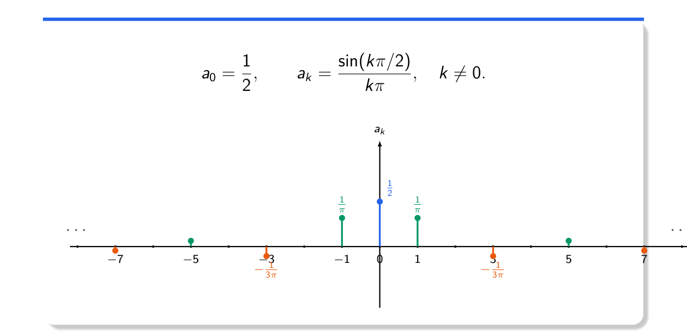
Figure 12.1 — Coefficients of the square wave with T₁ = T/4 (Lec 5, sl. 34)

3. Triangular Ramp, T = 3 (sl. 35–41)
x = t (0 ≤ t < 1), (3 − t)/2 (1 ≤ t < 3). a₀ = area/period = (½·3·1)/3 = ½ (geometry, sl. 37). For k ≠ 0 the integrals give (e^{−jkω₀} − 1)/(2k²ω₀²).
TRAP Slide 39 has a sign slip in the second integral, so slides 40–41 print a_k = (e^{−jkω₀} − 1)/(6k²ω₀²). The correct value is (e^{−jkω₀} − 1)/(2k²ω₀²), ω₀ = 2π/3 (checked numerically; quickest derivation: x″ has impulses +3/2 at t = 0 and −3/2 at t = 1 per period, so (jkω₀)²a_k = (1/3)(3/2)(1 − e^{−jkω₀})).

4. Trigonometric Forms (textbook)
x(t) = a₀ + Σ_{n≥1} [aₙ cos nω₀t + bₙ sin nω₀t] aₙ = (2/T)∫x cos nω₀t dt, bₙ = (2/T)∫x sin nω₀t dt
= C₀ + Σ Cₙ cos(nω₀t + θₙ) (compact) Cₙ = √(aₙ² + bₙ²), θₙ = −tan⁻¹(bₙ/aₙ)
Exponential ↔ trig: c₀ = a₀; cₙ = (aₙ − jbₙ)/2; c₋ₙ = cₙ*; Cₙ = 2|cₙ|

Exam Approach
1. Sum of sinusoids → inspection; rewrite sines as cosines with phase, collect same frequencies.
2. Standard waveform → integrate over the most convenient period; k = 0 separately.
3. Piecewise-linear waveform → differentiate twice to get impulses (Lesson 14), then divide by (jkω₀)².
4. Spectra: plot |a_k| (even) and ∠a_k (odd) against k or kω₀.

Practice — Lesson 12
(a) Actual — EEE 211 2022-23 Q5(a). (b) Actual — EEE 211 2018-19 Q1(b). (c) Actual — CSE 311 2019-20 Q1(a), 2020-21 Q2(b). (d) Actual — EEE 211 2019-20 Q8(b). (e) Older: EEE 211 2017-18 Q4(a), EEE 301 2013-14 Q3(b), 2010-11 Q1(a).
(a) Compact trigonometric FS and amplitude spectrum of x = 2 + 3cos2t + 4sin2t + 2sin(3t + 30°) − cos(7t + 150°). (10)
(b) Exponential FS and magnitude/phase spectra of x = 2 + ½cos(t + 45°) + 2cos3t − sin(4t + 30°). (10)
(c) Exponential FS coefficients of cos 2πf₀t and sin 2πf₀t: real or imaginary? Must we integrate over a full cycle? (17)
(d) Triangular wave, period 2: x(0) = −A, x(±1) = A, linear in between (zero crossings at ±½). a₀, aₙ, bₙ. (20)
(e) (i) 3 + cos(4t + π/4) + sin(10t + π/3) (trig coefficients); (ii) triangle wave rising from 0 at t = 0 to 2 at t = π/2 and back to 0 at t = π, period π; (iii) square wave K of width τ, period T: Cₙ and the effect of T.

✔ Solution
(a) ω₀ = 1. 3cos2t + 4sin2t = 5cos(2t − 53.13°); 2sin(3t + 30°) = 2cos(3t − 60°);
−cos(7t + 150°) = cos(7t − 30°)
x = 2 + 5cos(2t − 53.13°) + 2cos(3t − 60°) + cos(7t − 30°)
amplitude spectrum: C₀ = 2, C₂ = 5, C₃ = 2, C₇ = 1 (all others 0)
(b) ω₀ = 1. c₀ = 2; c±₁ = ¼e^{±j45°}; c±₃ = 1; −sin(4t + 30°) = cos(4t + 120°) ⇒ c±₄ = ½e^{±j120°}
|c|: 2 (k=0), ¼ (±1), 1 (±3), ½ (±4); ∠c: ±45° (k = ±1), 0 (±3), ±120° (±4)

(c) cos 2πf₀t = ½e^{j2πf₀t} + ½e^{−j2πf₀t} ⇒ a±₁ = ½ (real). sin 2πf₀t = (1/2j)e^{j2πf₀t} − (1/2j)e^{−j2πf₀t} ⇒ a±₁ = ∓j/2 (purely imaginary). Both satisfy Dirichlet (bounded, smooth, one max/min per period). In general a_k needs a full period; for even signals a_k = (2/T)∫₀^{T/2}x cos kω₀t dt and for odd signals a_k = (−2j/T)∫₀^{T/2}x sin kω₀t dt — half a cycle suffices (Lesson 13).
(d) x(t) = A(2|t| − 1), |t| ≤ 1, period 2 (ω₀ = π). Even ⇒ bₙ = 0. a₀ = average = 0 (equal areas above and below).
aₙ = (2/2)∫_{−1}^{1} A(2|t| − 1)cos nπt dt = 2A∫₀¹(2t − 1)cos nπt dt = 4A[(−1)ⁿ − 1]/(n²π²)
= −8A/(n²π²) for odd n, 0 for even n
x(t) = −(8A/π²)[cos πt + (1/9)cos 3πt + (1/25)cos 5πt + …]

(e)(i) ω₀ = 2: a₀ = 3; a₂ = cos π/4 = 0.707, b₂ = −sin π/4 = −0.707;
sin(10t + π/3) = (√3/2)cos10t + ½ sin10t ⇒ a₅ = 0.866, b₅ = 0.5
(ii) ω₀ = 2, even about π/2: c₀ = 1; c_k = −4/(π²k²) for odd k, 0 for even k ≠ 0
x = 1 − (8/π²)Σ_{odd} cos(2kt)/k²
(iii) Cₙ = (Kτ/T)·sin(nπτ/T)/(nπτ/T); τ = 1: T = 5, 10, 15 ⇒ line spacing 2π/T shrinks and every line
shrinks (∝ 1/T) while the sinc envelope (zeros at multiples of 2π/τ) stays fixed

Lesson 13 — Linearity, Shift, Reversal, Scaling and Symmetry
Slides 2–35 (Lec 6) · symmetry rules: textbook
Property | Signal (same T) | Coefficients
Linearity (sl. 5–8) | αx + βy | αa_k + βb_k
Time shift (sl. 9–17) | x(t − t₀) | a_k e^{−jkω₀t₀} (magnitude unchanged)
Reversal (sl. 18–23) | x(−t) | a₋ₖ
Scaling (sl. 27–33) | x(αt), α > 0 | a_k, but ω₀ → αω₀ (period T/α)
Conjugation | x*(t) | a*₋ₖ

Worked (sl. 24–26, 34–35): x(4 − t) + y(t − 3) ↔ a₋ₖe^{−j4kω₀} + b_k e^{−j3kω₀}; x(4 − 3t) ↔ a₋ₖe^{−j4kω₀} with ω₀′ = 3ω₀ (shift, then reverse, then scale — the coefficient does not change in the last step).
TRAP Slide 26 writes y(t − 3) ↔ a_k e^{−j3kω₀}; it must be b_k e^{−j3kω₀} (y has coefficients b_k), as the boxed final answer shows.

Symmetry Rules (textbook)
Signal | Coefficients
real | a₋ₖ = a_k* (|a_k| even, ∠a_k odd)
real and even | a_k real and even (cosine terms only)
real and odd | a_k purely imaginary and odd, a₀ = 0 (sine terms only)
half-wave symmetric: x(t + T/2) = −x(t) | a_k = 0 for every even k (odd harmonics only)

Proof of even → real: a_k = (1/T)∫_{−T/2}^{T/2} x(t)[cos kω₀t − j sin kω₀t]dt; x·sin is odd, so its integral vanishes and a_k = (2/T)∫₀^{T/2} x cos kω₀t dt is real. For odd x the cosine part vanishes: a_k = −(2j/T)∫₀^{T/2} x sin kω₀t dt, imaginary. Both need only half a cycle.

Exam Approach
1. Write the new signal as a chain of operations on the known one.
2. Apply the rules in the same order (shift → reverse → scale), updating ω₀ after scaling.
3. Use symmetry to predict which coefficients vanish and whether they are real/imaginary — a free check.

Practice — Lesson 13
(a) Actual — CSE 219 2023-24 Q4. (b) Actual — CSE 219 2022-23 Q5(d). (c) Actual — CSE 311 2022-23 Q1(a), 2018-19 Q2(b). (d) Actual — EEE 301 2011-12 Q1(a).
(a) x(t) = A (0 < t < T₀/2), −A (−T₀/2 < t < 0), periodic; y(t) = x(t − T₀/6). (a) Show y has half-wave symmetry. (b) Find Y_k from X_k. (c) Magnitude/phase spectra up to k = 5. (d) Compare the trigonometric series of x and y. (5 + 10 + 10 + 5)
(b) Is x(t) = Σ_{k=0}¹⁰⁰(½)^k e^{jk2πt/50} real-valued? even? (5)
(c) Show that the exponential FS coefficients of an even (odd) periodic signal are real (imaginary) and can be computed over half a cycle. (15–17)
(d) x is real and odd, T = 2, c_k = 0 for |k| > 1, ½∫₀²|x|²dt = 1. Give two signals that satisfy this. (18)

✔ Solution
(a) X_k = (1/T₀)[∫₀^{T₀/2} A e^{−jkω₀t}dt − ∫_{−T₀/2}^{0} A e^{−jkω₀t}dt] = (A/(jkπ))[1 − (−1)^k]
X_k = 2A/(jπk) for odd k, 0 for even k (half-wave symmetric, real-odd ⇒ imaginary)
(a) y(t + T₀/2) = x(t + T₀/2 − T₀/6) = −x(t − T₀/6) = −y(t) ✓ (a shift keeps half-wave symmetry)
(b) Y_k = X_k e^{−jkω₀T₀/6} = X_k e^{−jkπ/3} = (2A/(jπk)) e^{−jkπ/3}, odd k; 0 for even k
(c) |Y_k| = 2A/(π|k|): k = ±1: 0.637A, ±3: 0.212A, ±5: 0.127A
∠Y_k = −π/2 − kπ/3 (k > 0): k=1: −5π/6; k=3: −3π/2 ≡ +π/2; k=5: −13π/6 ≡ −π/6 (odd in k)
(d) x(t) = Σ_{odd k} (4A/(πk)) sin kω₀t; y(t) = Σ_{odd k} (4A/(πk)) sin(kω₀t − kπ/3)
same amplitudes (only odd harmonics); each harmonic phase-shifted by −kπ/3 (∝ k: pure delay)

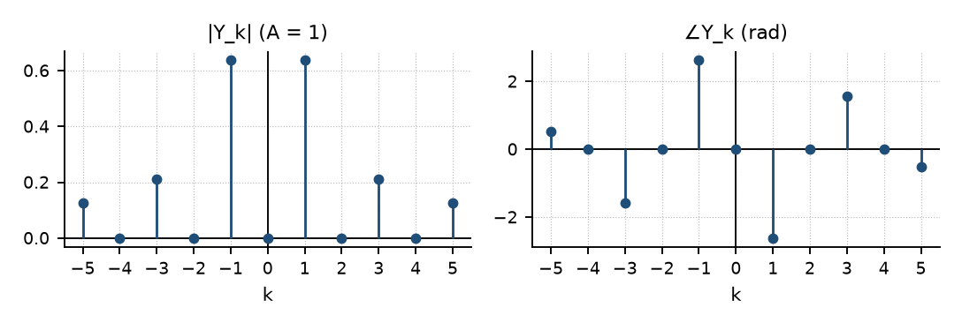
Figure 13.1 — Spectra of y(t) = x(t − T₀/6) for CSE 219 2023-24 Q4 (A = 1)
(b) Real requires a₋ₖ = a_k. Here a_k = (½)^k for 0 ≤ k ≤ 100 but a₋ₖ = 0 ≠ a_k ⇒ not real. Even requires a₋ₖ = a_k ⇒ not even either (x is a sum of positive-frequency exponentials only).
(c) Proof in the box above (split e^{−jkω₀t} into cos − j sin and use odd × even = odd).
(d) Real odd with only k = ±1 ⇒ x = B sin πt (ω₀ = π). Power ½∫₀²B²sin²πt dt = B²/2 = 1 ⇒ B = ±√2: x₁ = √2 sin πt and x₂ = −√2 sin πt.

Lesson 14 — Differentiation, Impulses, Impulse Trains, Integration
Slides 36–72 (Lec 6)
dx/dt ↔ jkω₀ a_k ∫x dt ↔ a_k/(jkω₀) (k ≠ 0; find a₀ separately)
Every harmonic is a rotating arrow; differentiating gives its velocity: speed |kω₀||a_k|, direction tangent — multiplication by j (sl. 37–39). Example: d/dt x(4 − 3t) ↔ j3kω₀ a₋ₖ e^{−j4kω₀} (use the current ω₀′ = 3ω₀).
Derivative sketch (sl. 42–44): slopes between jumps + impulses equal to each jump. Sifting (sl. 45–51): ∫eᵗδ(t)dt = 1; ∫₁^∞ eᵗδ(t)dt = 0 (outside); ∫₋₅⁵eᵗ[δ(t+1) + 2δ(t−2)]dt = e⁻¹ + 2e².

Impulse Train (sl. 52–56)
Σₘ δ(t − mT) ↔ a_k = 1/T for every k trig form: 1/T + (2/T)Σ cos(2πnt/T)
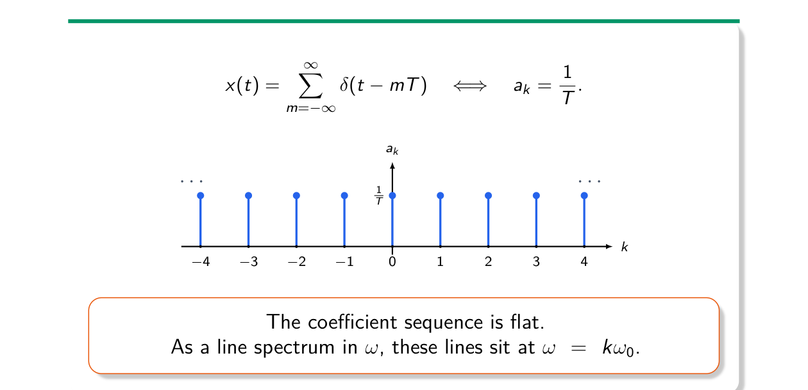
Figure 14.1 — An impulse train has a flat line spectrum (Lec 6, sl. 55)

Two Worked Uses (sl. 57–72)
Rectangular pulse train: dx/dt = δ(t + T₁) − δ(t − T₁) per period ⇒ b_k = (1/T)(e^{jkω₀T₁} − e^{−jkω₀T₁})
= (2j/T) sin kω₀T₁ = jkω₀ · sin(kω₀T₁)/(kπ) ✓
Sawtooth x = t (0 ≤ t < 1), T = 1: dx/dt = 1 − Σδ(t − m) ⇒ b₀ = 0, b_k = −1
a_k = b_k/(jkω₀) = −1/(j2πk) = j/(2πk), a₀ = ∫₀¹ t dt = ½

Exam Approach
1. Piecewise-constant or piecewise-linear x: differentiate until only impulses remain.
2. Impulse coefficients by sifting: δ(t − t₀) in one period ↔ (1/T)e^{−jkω₀t₀}.
3. Divide by (jkω₀)^m; get a₀ from the average.
4. Trains with alternating signs = sum of shifted trains.

Practice — Lesson 14
(a) Actual — EEE 211 2022-23 Q8(a). (b) Actual — EEE 211 2019-20 Q7(a). (c) Actual — EEE 211 2020-21 Q7(a). (d) Actual — EEE 301 2014-15 Q4(a), 2015-16 Q6(a).
(a) Trigonometric FS (A₀ + ΣAₙcos(2πnt/T₀ + φ)) of δ_{T₀}(t); amplitude spectrum. (20)
(b) Exponential FS of (i) unit impulses at every integer; (ii) impulses −1 at even integers and +1 at odd integers. (15)
(c) x(t) = 1 − |t| on [−2, 2], period 4 (triangle between ±1); y(t) = 4 on (0, 2), 0 on (2, 4), period 4. Find the exponential FS of x, then y by properties; amplitude spectra. (20)
(d) C_n = ½[1 − (−1)ⁿ], T = 20 ms: real signal? find x(t). Impulse train: FS, FT, PSD.

✔ Solution
(a) a_k = 1/T₀ for all k ⇒ δ_{T₀}(t) = 1/T₀ + (2/T₀)Σ_{n≥1} cos(2πnt/T₀): A₀ = 1/T₀, Aₙ = 2/T₀, φ = 0. Amplitude spectrum: a line of height 1/T₀ at n = 0 and 2/T₀ at every harmonic n·(1/T₀) Hz.
(b) (i) T = 1: a_k = 1 for all k ⇒ x = Σ e^{j2πkt}. (ii) T = 2, one period has −δ(t) and +δ(t − 1): a_k = ½[−1 + e^{−jkπ}] = ½[(−1)^k − 1] = −1 for odd k, 0 for even k ⇒ x = −Σ_{odd k} e^{jkπt} = −2Σ_{odd}cos kπt.
(c) x′ = −1 on (0,2), +1 on (−2,0); x″ = 2δ(t + 2) − 2δ(t) per period (T = 4, ω₀ = π/2)
(jkω₀)² a_k = (1/4)[2e^{jkπ} − 2] ⇒ a_k = (1 − (−1)^k)/(2·k²π²/4) = 4/(k²π²) for odd k, 0 even; a₀ = 0
y = 2 − 2x′(t) (x′ = −1 on (0,2) gives 4, +1 on (2,4) gives 0)
b₀ = 2; b_k = −2·jkω₀ a_k = −2j(kπ/2)(4/(k²π²)) = −4j/(πk) for odd k, 0 for even k ≠ 0
|a_k| = 4/(π²k²): 0.405, 0.045, 0.016 (k = 1, 3, 5); |b_k| = 4/(π|k|): 1.273, 0.424, 0.255; |b₀| = 2

(d) C_n = 1 for odd n, 0 for even n (C₀ = 0). C₋ₙ = Cₙ* and real ⇒ x is real and even. x = Σ_{odd n} e^{jnω₀t}, ω₀ = 2π/0.02 = 100π rad/s. Since Σ_{all}e^{jnω₀t} = T₀Σδ(t − kT₀) and the even-n part is (T₀/2)Σδ(t − kT₀/2), x(t) = (T₀/2)Σ_k(−1)^kδ(t − kT₀/2) = 0.01Σ(−1)^kδ(t − 0.01k): alternating impulses every 10 ms. Impulse train δ_T: FS a_k = 1/T; FT (2π/T)Σδ(ω − 2πk/T); PSD S(ω) = (2π/T²)Σδ(ω − 2πk/T).

Lesson 15 — Multiplication, Parseval, and Periodic Inputs to LTI Systems
Slides 73–81 (Lec 6) · Parseval and LTI response: textbook
x(t)y(t) ↔ c_k = Σₚ aₚ b_{k−p} (convolution of coefficients)
Proof (sl. 75–78): put z = e^{jω₀t}; each series is a polynomial in z, and the product's z^k coefficient collects pairs with p + q = k. Example: x = 1 + cos ω₀t (a₀ = 1, a±₁ = ½) ⇒ x² ↔ {¼, 1, 3/2, 1, ¼} for k = −2…2; check: (1 + cos)² = 3/2 + 2cos ω₀t + ½cos 2ω₀t ✓.

Parseval and Power (textbook)
P = (1/T)∫_T |x|² dt = Σ |a_k|² (= C₀² + Σ Cₙ²/2 in compact trig form)

Periodic Input to an LTI System (textbook)
e^{jkω₀t} is an eigenfunction: it comes out as H(jkω₀)e^{jkω₀t}. So a periodic input with coefficients a_k gives a periodic output (same T) with
y_k = H(jkω₀) a_k A cos(ω t + θ) → A|H(jω)| cos(ωt + θ + ∠H(jω))
MEMORIZE Distortionless system (EEE 2017-18 Q1(b)): H = K e^{−jωt_d} ⇒ y_k = K e^{−jkω₀t_d} a_k (same magnitudes ×K, phase linear in k). Ideal LPF with cutoff ω_c: keep only harmonics with |kω₀| < ω_c.

Exam Approach
1. Find a_k of the input (inspection / standard waveform).
2. Find H(jω) of the system (circuit: voltage divider with jωL, 1/(jωC); ODE: replace d/dt by jω).
3. Multiply harmonic by harmonic; list magnitudes and phases.
4. Power: Parseval on the output coefficients.

Practice — Lesson 15
(a) Actual — EEE 211 2023-24 Q7(b). (b) Actual — EEE 211 2020-21 Q7(b). (c) Actual — EEE 211 2019-20 Q5(b). (d) Actual — EEE 211 2021-22 Q3(a). (e) Older: EEE 211 2017-18 Q1(c), EEE 301 2015-16 Q4(b), 2011-12 Q1(b), 2012-13 Q4(b), EEE 211 2018-19 Q3(c).
(a) Half-wave rectified sine x(t) = sin(2πt/T) on the first half period, T = 0.5 ms, feeds (1) a differentiator, (2) a LPF with |H₂| = 5, linear phase (±π/2 at ±f_c), f_c = 1 kHz. (i) FS coefficients of y₁ from those of x. (ii) y₂(t); which harmonics survive? (iii) Compare the two systems. (25)
(b) y″ + 3y′ + 2y = x′ + x, x = 2cos t + 6cos 3t: amplitude and phase spectra of y; average power by Parseval. (15)
(c) Full-wave rectified sin t feeds an RC low-pass (R = 15 Ω, C = 1/5 F, output across C). H(ω) and y(t). (20)
(d) Period 4: x = δ(t − 1) + 2[u(t − 2) − u(t − 4)] in one period, applied to a 0.1 H series inductor, 100 µF shunt capacitor and 1 kΩ load. Magnitude and phase spectra of x and y. (20)
(e) Older (see solutions).

✔ Solution
(a) f₀ = 2 kHz, ω₀ = 4000π. Half-wave rectified sine (amplitude 1):
a₀ = 1/π, a±₁ = ∓j/4, a_k = −1/(π(k² − 1)) for even k, 0 for odd |k| ≥ 3
(i) Differentiator H₁ = jω: b_k = jkω₀ a_k ⇒ b₀ = 0, b±₁ = (jω₀)(∓j/4)·(±1) = ω₀/4 = 1000π,
b_k = −jkω₀/(π(k² − 1)) = −j4000k/(k² − 1) for even k
(ii) LPF passes |f| < 1 kHz only: the lowest harmonic is 2 kHz ⇒ only DC survives:
y₂(t) = H₂(0)a₀ = 5/π ≈ 1.59 (constant; harmonic k = 0 only)
(iii) the differentiator scales harmonic k by |k|ω₀ — it boosts high frequencies and removes DC;
the LPF removes everything except DC — it keeps the average and rejects all harmonics

(b) H(jω) = (jω + 1)/((jω)² + 3jω + 2) = 1/(jω + 2)
ω = 1: |H| = 1/√5, ∠H = −26.57°; ω = 3: |H| = 1/√13, ∠H = −56.31°
y = (2/√5)cos(t − 26.57°) + (6/√13)cos(3t − 56.31°) = 0.894cos(t − 26.57°) + 1.664cos(3t − 56.31°)
P = ½(0.894² + 1.664²) = ½(4/5 + 36/13) = 1.785 W (1-Ω basis)
(c) |sin t| = 2/π − (4/π)Σ_{k≥1} cos 2kt/(4k² − 1) (T = π, ω₀ = 2)
RC = 3: H(ω) = 1/(1 + j3ω)
y(t) = 2/π − (4/π)Σ |H(j2k)| cos(2kt − tan⁻¹6k)/(4k² − 1)
= 0.637 − 0.0698cos(2t − 80.54°) − 0.0070cos(4t − 85.24°) − … (nearly pure DC)
(d) a₀ = (1 + 4)/4 = 5/4; a_k = ¼e^{−jkπ/2} + j(1 − (−1)^k)/(kπ) (ω₀ = π/2)
a±₁ = ±j(1/π·2 − ¼) = ±j0.387; a±₂ = −¼; a±₃ = ±j(2/(3π) + ¼) = ±j0.462; a₄ = ¼ …
H(jω) = 1/(1 − ω²LC + jωL/R), LC = 10⁻⁵, L/R = 10⁻⁴ ⇒ |H(jkπ/2)| = 1.000, ∠H ≈ −0.01° for low k
⇒ output spectrum ≈ input spectrum (the filter's corner, 1/√(LC) = 316 rad/s, is far above kω₀ for small k)

(e) EEE 211 2017-18 Q1(c): H passes |ω| ≤ 3π ⇒ y = 1 + 2cos2πt (cos4πt, cos6πt removed)
EEE 301 2015-16 Q4(b): a±₁ = ½, b±₁ = ±1/(2j) ⇒ c₀ = 0, c₂ = 1/(4j), c₋₂ = −1/(4j) ⇒ z = ½ sin 8πt
EEE 301 2011-12 Q1(b): x = 2 + square wave (±1, T = 8, ω₀ = π/4); H(0) = 4; odd harmonics at kπ/4 meet
H = sin(kπ)/(kπ/4) = 0 ⇒ y(t) = 4·2 = 8 (constant)
EEE 301 2012-13 Q4(b): half-wave cos t: 2nd and 4th harmonic amplitudes 2/(3π) = 0.212, 2/(15π) = 0.042;
the LC–R network has |H| ≈ 1 at ω = 2, 4 (LC = 10⁻⁵) ⇒ output amplitudes ≈ 0.212 and 0.042
EEE 211 2018-19 Q3(c): T = 2, ω₀ = π, C_n = 1 (odd n); the band 2π < |ω| < 4π passes only n = ±3 ⇒
y = 2cos(3πt − π/2) = 2 sin 3πt (with −π/2 for ω > 0); h(t) = band-pass with −j sgn ω (method)

Quick Notes — Fourier Series
Revision points for Lessons 11–15.

L11 · Idea, Orthogonality
- x = Σ a_k e^{jkω₀t}, a_k = (1/T)∫_T x e^{−jkω₀t}dt, a₀ = average.
- Orthogonal: ∫φᵢφⱼ* = 0; normalize by 1/√E; cᵢ = ⟨x, φᵢ⟩/Eᵢ.
- Dirichlet: absolutely integrable, finite extrema, finite jumps — sufficient, not necessary.

L12 · Coefficients
- Square wave: a₀ = 2T₁/T, a_k = sin(kω₀T₁)/(kπ).
- Ramp (T = 3): a₀ = ½, a_k = (e^{−jkω₀} − 1)/(2k²ω₀²) (slide prints 6).
- cₙ = (aₙ − jbₙ)/2, Cₙ = 2|cₙ|.

L13 · Properties
- Shift: a_k e^{−jkω₀t₀}; reverse: a₋ₖ; x(αt): same a_k, ω₀ → αω₀.
- Real: a₋ₖ = a_k*; even → real; odd → imaginary; half-wave → odd harmonics only.

L14 · Derivative, Trains
- dx/dt ↔ jkω₀a_k; ∫ ↔ a_k/(jkω₀) (a₀ separately).
- Σδ(t − mT) ↔ 1/T. Sawtooth t (T = 1): a₀ = ½, a_k = j/(2πk).

L15 · Products, LTI
- xy ↔ Σ aₚb_{k−p}. P = Σ|a_k|².
- LTI: y_k = H(jkω₀)a_k.

Key Diagrams to Reproduce
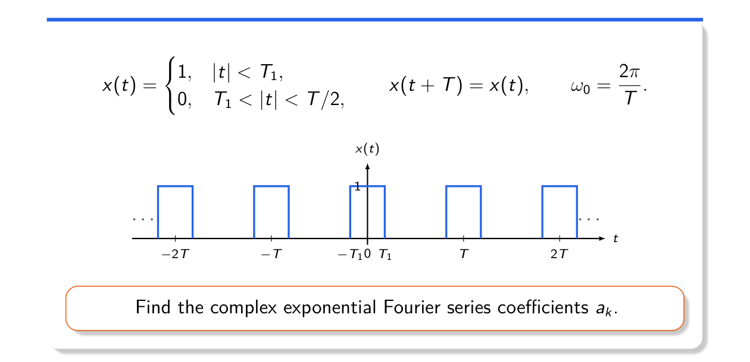
The periodic square wave (Lec 5, sl. 30)
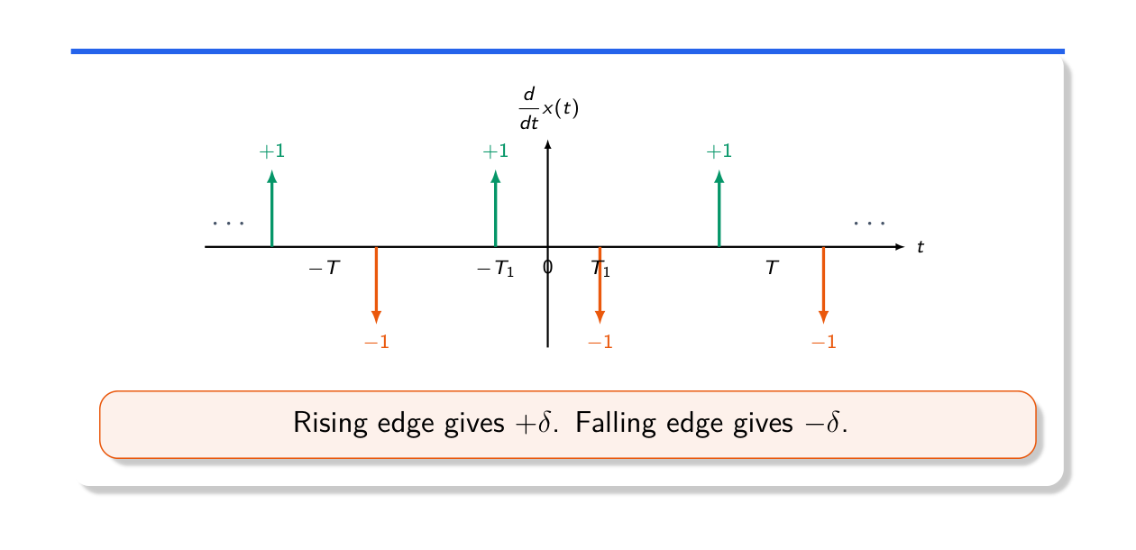
Derivative of the rectangular pulse train (Lec 6, sl. 59)

